Robotics Process Automation Design and Development (UiPath) – BCG701 Lab
Experiment No: 1
Title: Develop automation in UiPath StudioX to demonstrate the following activities: Write Line: Message Box, Input Dialog. Modify Text., Text to Left/Right and Delay.

Aim: To develop an automation in UiPath StudioX to demonstrate the following activities:
- Write Line
- Message Box
- Input Dialog
- Modify Text
- Text to Left/Right
- Delay

Theory:
- Write Line: The Write Line activity allows you to print a specified message to the Output panel. The Write Line activity is beneficial during and after the development phase of automation.
- Message Box: The Message Box activity allows you to pause the automation and display text with specified buttons in a message box. The Message Box activity is particularly useful during the development phase of automation. Adding this activity can help you follow the flow of automation and debug any issues that might arise during development.
- Input Dialog: The Input Dialog activity allows you to prompt the user to provide input. This activity is particularly useful in attended automation for processes that require user input.
- Modify Text: The Modify Text activity allows you to modify the input text value by performing different operations.
- Text to Left/Right: The Text to Left/Right activity allows you to split a text value into two text values using a separator.
- Delay: The Delay activity allows you to pause your automation for a specified number of seconds. At times, issues such as slow system performance and latency in the network are unavoidable. The Delay activity can be useful in ensuring that such issues do not cause automation failures. This activity will help make your automation more robust and less prone to failure.

Conduction:

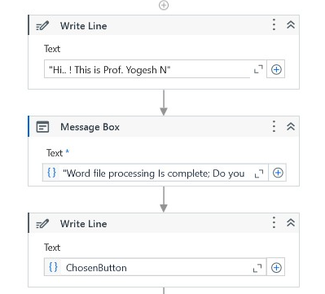

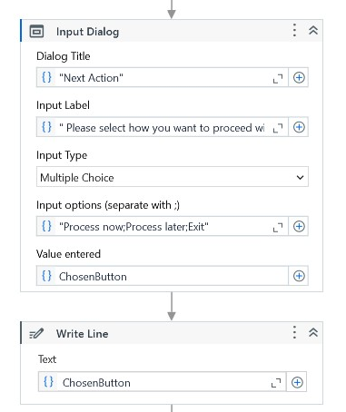

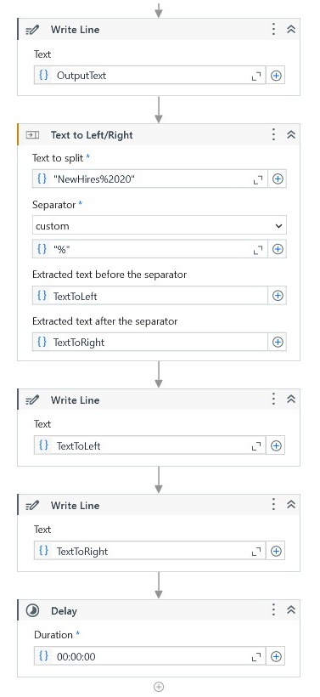
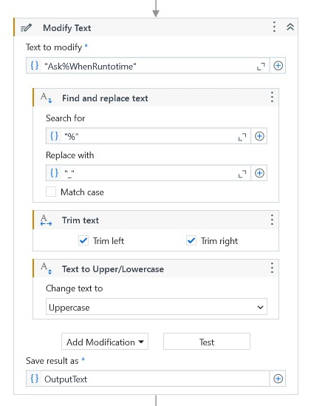

Output:
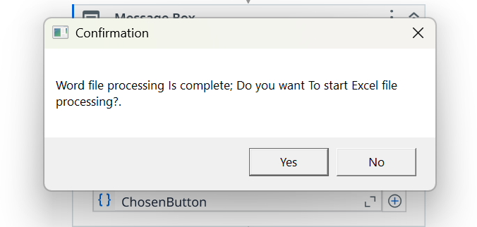

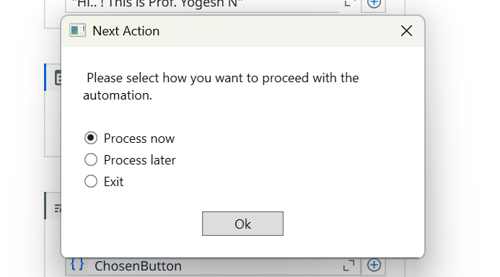
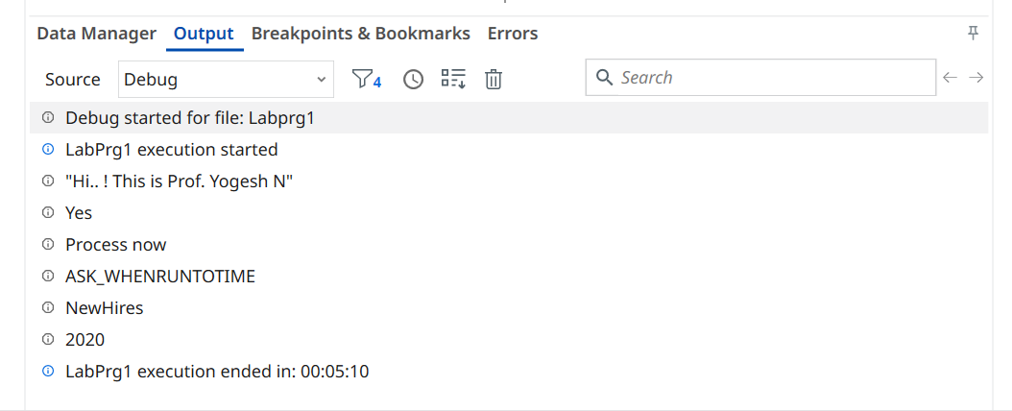

Observation and Results:
The following activities are demonstrated and executed using UiPath StudioX:
- Write Line
- Message Box
- Input Dialog
- Modify Text
- Text to Left/Right
- Delay

The output for the above-mentioned activities is verified.

Evaluation:
Evaluation Parameters | Maximum Marks | Obtained Marks
Conduction | 8
Record Writing | 4
Viva | 3
Total | 15

Signature of the Faculty incharge with date:

